Time to act on domestic violence
Date: March 7, 2014

EDITORIAL
In the shadows behind the curtains, in the black of night. In the disturbed minds of those who said they loved you, in the bruises you hide. In the murky depths of despair, desperate to escape. In the emptiness all alone, frozen in fear. In the cold dark days you stay, for the sake of the kids. When will you be safe?
Domestic violence ruins lives. For every high-profile case, more victims die shrouded in silence and countless others endure the daily torture of not knowing when it will happen again.
Far too often we as neighbours, family, friends and fellow Australians fail to see it. Even worse, we turn a blind eye.
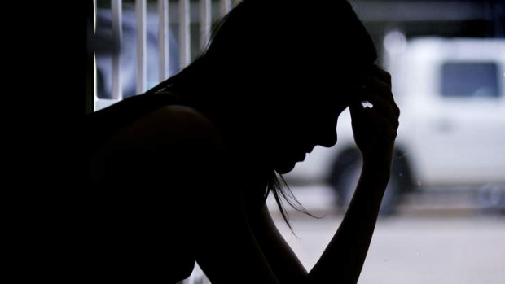
In Australia, one woman dies every week from from domestic violence in 2014. Photo: Roslyn Smith
It is time to Shine a Light on domestic violence.
Advertisement
To mark International Women's Day on Saturday, the Herald and Daily Life have launched a year-long campaign to illuminate the public and our leaders on what remains a national tragedy for a country that purports to be civilised, tolerant and safe.
By placing domestic violence atop the national agenda we can expose and erase the dark underside of home life, while helping victims find the warmth and optimism they deserve.
Change will mean recasting many of the myths about what a significant minority of men regard as being Australian: rugged blokiness and the breadwinner rules. Never dob in your mates, don't show signs of weakness, can't talk about emotions and won't seek help. But will self-medicate for mental illness, will blame others for personal failures. Able to apply double standards to being faithful, forgive loss of control and embrace grog as a national right.
Change will require a recognition of the extent of the damage by those who behave as though it's still the dark ages.
One woman dies every week from domestic violence in Australia in 2014. In NSW, 24 women were killed last year in domestic-related incidents. Of all homicides in NSW, 42 per cent are domestic. One woman is hospitalised every three hours across the country.
Access Economics has estimated about 1.6 million Australian women have experienced domestic violence in some form.
That's just the official toll. Less than half the abuse is reported.
As NSW Police Commissioner Andrew Scipione says: "These are mothers, your daughters, your sisters, wives, girlfriends, these are the people that work at the desk next to you at work. These are real people and they are horrifying numbers."
Behind the veneer of social respectability across all demographics, women are suffering from physical, psychological, manipulative and controlling behaviour by culprits. It emanates from a mindset that blames the victim and tolerates disrespect for those who are of another gender, background, lifestyle or simply powerless.
Children are being assaulted, traumatised and used as weapons.
Change will require challenging the culture of saying nothing.
For so long the fear of social ostracism or economic desolation prompted women in particular not to report their dire situations. Witnesses felt it was a private matter or feared retribution.
There must be must be more protection of whistleblowers who lift the veil of secrecy.
True, more women today are economically independent and most know there are services out there to help if partners become abusive. Some take the risk of speaking out and refuse to be demeaned. But fewer still make the flight to safety or use the support of courts and the police to remain in their own homes.
Most live in fear of being tracked down by their abuser.
Granted, campaigns such as Say No to Violence and White Ribbon Day have helped increase awareness and change attitudes among many men, whose role in telling mates to stop is crucial.
Sadly, though, many culprits have responded by resorting to long-used mental abuse, often driven by a jealousy linked to low self-esteem. They try to destroy the confidence of a victim to the point where she and sometimes he feels a prisoner dependent on the captor.
In these cases early signs of abuse are even harder to identity. Researchers suggest the process can be so insidious that sometimes women are murdered without having endured a single act of physical violence up to that point.
Change will require the courage of society to stop allowing men to make excuses: it won't happen again, they were stressed and now they are sorry. No, they are committing criminal acts.
Yet studies show most Australians make excuses too, calling temporary anger and yelling abuse normal while shrugging off the seriousness of financial control as punishment.
Australians used to regard drunken behaviour by husbands as the norm too. Many men have grown up in families that functioned peacefully in those circumstances, yet many remain deeply affected.
Research shows the children of families that endured domestic violence are more likely to offend as adults.
This intergenerational problem remains, despite some changed attitudes on the role of alcohol in street assaults.
The Herald campaigned strongly for the O'Farrell government to tackle street violence.
Society needs to tackle domestic abuse ? as well because there is a common link: disrespect.
Role models on the sporting field too often fall short of respectful attitudes to women.
The spread of cyber bullying and trolling in social media only makes the task all the harder to show young boys who soon grow into men that disagreements can be settled peacefully and personality clashes need not become abusive.
There are some glimmers of hope. Family and Community Services Minister Pru Goward is chairing a new taskforce to examine sentencing options for perpetrators.
Victims will not have to retell their stories over and over when seeking help under plans for dedicated case managers and a centralised database. And social service workers believe Australians have had a gutful of maintaining a polite silence on domestic violence.
Through the Shine a Light campaign over the next year, the Herald and Daily Life aim to help bring Australia further out of the dark ages and make it easier for every family to live in safety, free from domestic violence.
Read more: http://www.smh.com.au/comment/smh-editorial/time-to-act-on-domestic-violence-20140307-34cqt.html#ixzz3ouRhMZZa
Follow us: @smh on Twitter | sydneymorningherald on Facebook

